Kaeser Compressors, Inc.
PO Box 946 Fredericksburg, VA 22404 USA
Phone: (540) 898-5500 us.kaeser.com

Press Contact: Michael Camber • (540) 684-9489
pr.us@kaeser.com

10/2/2023
FOR IMMEDIATE RELEASE

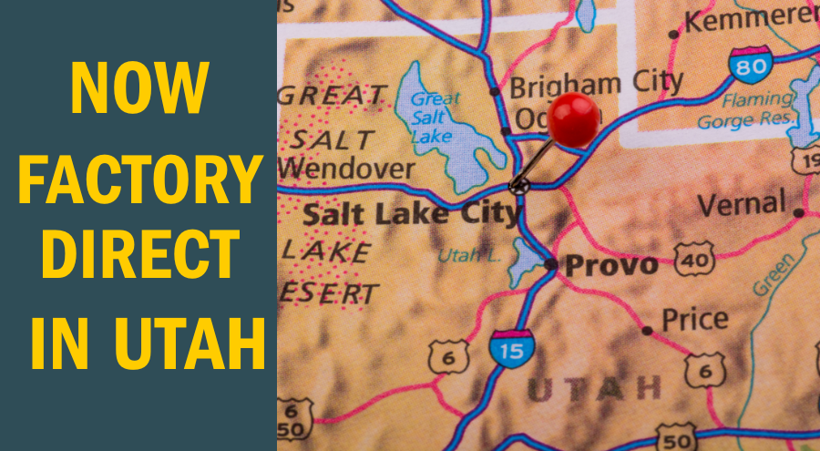 | Kaeser Compressors' new factory-direct facility in Salt Lake City will serve Utah and portions of Idaho, Wyoming, and Nevada.  Download a high-resolution image here.

KAESER IS NOW FACTORY-DIRECT IN UTAH

Kaeser Compressors’ factory-direct facility will support customers and prospects in Utah and portions of Idaho, Wyoming, and Nevada with sales, service, parts, engineering, and maintenance.

Kaeser Compressors is excited to announce the opening of a new branch office in Salt Lake City, Utah! The new factory store will cover Utah and portions of Idaho, Wyoming and Nevada. As always, our trained and certified sales and service professionals are ready to meet all our customers’ compressed air, blower, and vacuum needs.

“We are very excited to directly support our existing customers in the region,” said Julian Shelton, Salt Lake City Branch Manager. “Plus, we look forward to expanding our customer base and providing reliable, energy-efficient air systems to a broad range of industrial, commercial and institutional users. Whether you need new equipment, routine maintenance, or troubleshooting, Kaeser is here to help.” Factory-certified sales and service experts are now locally available to help assess each end user’s specific needs and tailor solutions, whether as a complete compressed air system installation or a contractual solution.

For more information, visit us.kaeser.com/saltlakecity, or call (888) 786-5413 to schedule a visit.

###

About Kaeser Compressors, Inc.: Kaeser Compressors is a leader in reliable, energy efficient compressed air equipment and system design. We offer a complete line of superior quality industrial air compressors as well as dryers, filters, SmartPipe™, master controls, and other system accessories. Kaeser also offers blowers, vacuum pumps, and portable gasoline and diesel screw compressors. Our national service network provides installation, rentals, maintenance, repair, and system audits. Kaeser is an ENERGY STAR Partner.

