Kaeser Compressors, Inc.
PO Box 946 Fredericksburg, VA 22404 USA
Phone: (540) 898-5500 us.kaeser.com

Press Contact: Michael Camber • (540) 684-9489
pr.us@kaeser.com

9/7/23
FOR IMMEDIATE RELEASE

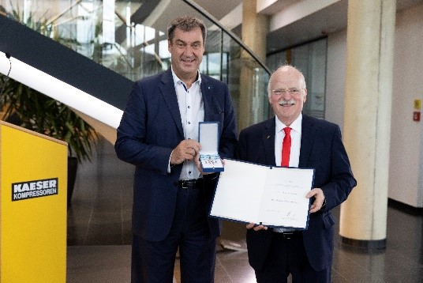 | Markus Söder, Minister-President of Bavaria, honored Thomas Kaeser with the Bavarian Order of Merit.  Download a high-resolution image here.

A Great Economic Leader

Thomas Kaeser, CEO of Kaeser Kompressoren, has been awarded the Bavarian Order of Merit for Outstanding Achievements in Business and Community Engagement

Thomas Kaeser, President and CEO of Germany’s Kaeser Kompressoren, has been awarded the Bavarian Order of Merit by Markus Söder, Minister-President of Bavaria. Kaeser is a highly successful economic leader and active member of the business community. In an Upper Franconian economy that has undergone extensive change, he has used structural transformation to help the economy locally and to grow Kaeser Kompressoren globally.

When presenting this prestigious honor, Söder stated, “He is a steadfast advocate for the Upper Franconian economy. He always has excellent ideas and suggestions for what can be done to benefit society.” Additionally, Söder emphasized that to receive the Bavarian Order of Merit one must accomplish something exceptional. “It cannot be bought or inherited; it must be earned,” he said.

In accepting this honor, Thomas Kaeser promised to continue applying his skills for the benefit of society as a whole as well as his company. He expressed his gratitude to the many people who have accompanied and shaped him throughout his life: his grandparents and parents, his six siblings, his friends and colleagues, the entire Kaeser Kompressoren staff of 7500 employees, and most especially his wife Tina-Maria and his sons Jan and Philipp. “I want to share a part of the Order with those who have supported and influenced me throughout my life,” he said.

About Thomas Kaeser
Thomas Kaeser is a native of Coburg, Germany. He is the grandson of Carl Kaeser, Sr., who founded Kaeser Kompressoren in 1919, and the son of Carl Kaeser, Jr., who led the company until 2009. Today Thomas Kaeser and his wife Tina-Maria Vlantoussi-Kaeser lead the family business with offices in over 140 countries. Mr. Kaeser is Chairman of the vbw-District Group of Upper Franconia, Chairman of the Western Region of the VBM and BayME, and CEO of the Association of the Metal and Electrical Industry in Thuringia. In addition, he is involved in the Board of the VDMA (Mechanical Engineering Industry Association), the Exhibitor and Trade Fair Advisory Board of the Hannover Messe, as well as the PNEUROP Council and the Exhibition and Trade Fair Committee of the German Economy (AUMA). In 2012, he was awarded the State Medal for Special Services to the Bavarian Economy.
About the Bavarian Order of Merit
The Bavarian Order of Merit has been awarded annually since 1957 as a symbol of honorable and grateful recognition for outstanding services to the Free State of Bavaria and the Bavarian people by the Minister-President. It symbolizes the extraordinary commitment and outstanding contributions of the citizens of the Free State to the community.

For more information, visit us.kaeser.com. For more information or to be connected with your local authorized Kaeser representative, please call (877) 417-3527

###

About Kaeser Compressors, Inc.: Kaeser Compressors is a leader in reliable, energy efficient compressed air equipment and system design. We offer a complete line of superior quality industrial air compressors as well as dryers, filters, SmartPipe™, master controls, and other system accessories. Kaeser also offers blowers, vacuum pumps, and portable gasoline and diesel screw compressors. Our national service network provides installation, rentals, maintenance, repair, and system audits. Kaeser is an ENERGY STAR Partner.

