Kaeser Compressors, Inc.
PO Box 946 Fredericksburg, VA 22404 USA
Phone: (540) 898-5500 us.kaeser.com

Press Contact: Michael Camber • (540) 684-9489
communications.us@kaeser.com

12/12/2023
FOR IMMEDIATE RELEASE

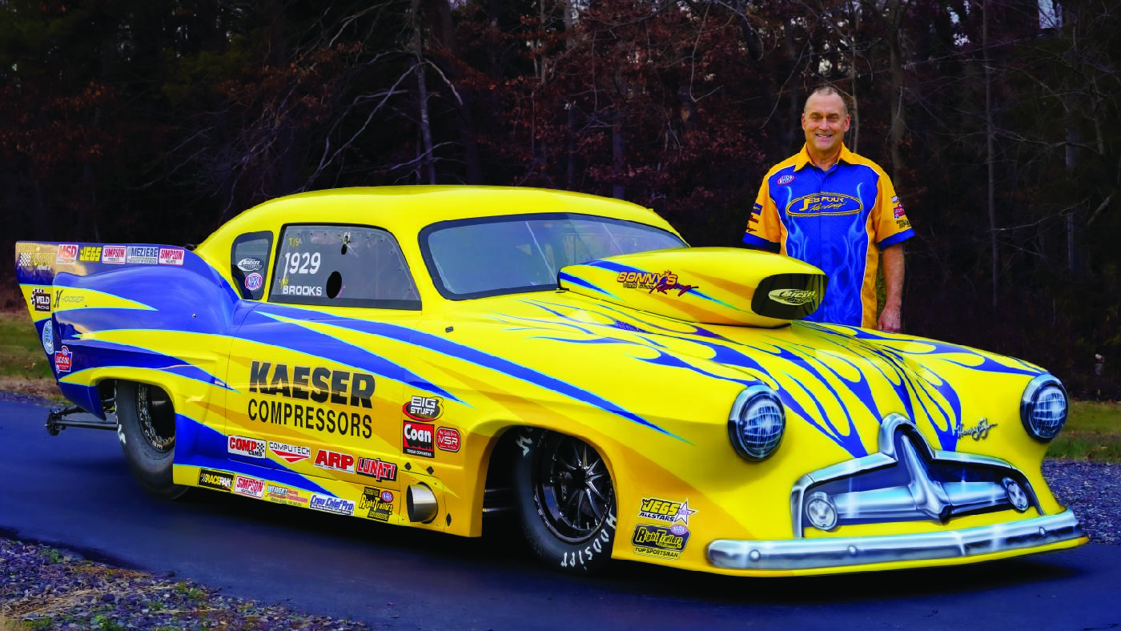 | The new JEB Four car is ready for the 2024 NHRA season.  Download a high-resolution image here.

FAN-FAVORITE DRAGSTER NEWLY REDESIGNED

JEB Four Racing reveals their all-new Henry J dragster.

Kaeser Compressors and JEB Four Racing are proud to present a redesigned dragster for the 2024 season.

JEB Four Racing is a nationally ranked NHRA drag racing team well-known for their unique Top Sportsman Henry J. With 15 national and divisional event wins, JEB Four is a two-time NHRA Northeast Division champion and finished the 2023 season fourth in the Central Division. They boast a career-best of 6.32 seconds in 1/4 mile, with top speeds over 220 mph.

After many successful years, a major redesign was needed to remain competitive in the Top Sportsman class. The team chose Jerry Bickel Race Cars for the new chassis design and integration. Kirkman Composites built the full carbon fiber body from Terry Hall's unique mold. Jeff Hoskins executed a flawless new paint scheme by Gos Motorsports Graphics. Under the hood, the dragster is powered by a Sonny Leonard 762-cubic inch Next Generation Hemi engine and is equipped with the Big Stuff 3 EFI system. The transmission is a Powerglide by Weaver's Racing Transmission, paired with a Coan Engineering torque converter.

Based on the classic 1951 Henry J economy car built by the Kaiser-Frazer Corporation, the JEB Four Henry J is one of the most recognized cars in drag racing and remains the only one of its kind in US drag racing. JEB Four Racing has been running variations of the Henry J since they started running the Super Gas class thirty years ago. Team founder James Brooks raced an original Henry J in the 1960s.
Kaeser is proud of its nearly 30-year sponsorship of JEB Four Racing, and we look forward to their success in 2024 and beyond.
For more information, visit us.kaeser.com/jeb4.

Follow JEB Four Racing
Instagram: @jebfourracing
Facebook: @jebfourracing
###

About Kaeser Compressors, Inc.: Kaeser Compressors is a leader in reliable, energy-efficient compressed air equipment and system design. We offer a complete line of superior-quality industrial air compressors, dryers, filters, SmartPipe™, master controls, and other system accessories. Kaeser also offers blowers, vacuum pumps, and portable gasoline and diesel screw compressors. Our national service network provides installation, rentals, maintenance, repair, and system audits. Kaeser is an ENERGY STAR Partner.

